Results
Breeding probability
The top model did not include previous breeding state as a covariate, but models with previous breeding state as a predictor of Ψ (the probability of moving into the ‘Breeder’ state) had a combined AIC weight of 0.48, and 3 models containing this covariate were within 2 AICc of the top model. Model selection therefore provided a moderate degree of support for effects of previous breeding state on current breeding effort (Table 3). However, the model-averaged effect size (difference in Ψ probability between breeders and non-breeders from the previous year) was < 0.01 (Figure 1). Model selection did not support PDO as a predictor of Ψ (Table 4). Social group size had a combined AIC weight of 0.28 (Table 4), but the Group covariate was only present in one model within 2 AICc of the top model. The best model did not include annual variation in breeding probability (Table 3), and model-averaged Ψ estimates varied by less than 1 SE from year to year in both age-classes (Fig. 1).
Age-class had the strongest support of any model covariates, and had the largest effect size (Table 4; Fig. 1). Annual variation in Ψ was more pronounced for females in their first year of reproductive maturity, but the uncertainty in parameter estimates was also greater for this age-class (Fig. 1). On average, the breeding probability of females four years old or older was 0.33 greater than that of three-year-old individuals (Fig. 1).
When model-averaged parameters were used to predict the number of breeding females in a subset of the population during 2007-2009, the results were within 1-2 litters of the observed values in each year (Table 5). Year-to-year variation in the number of breeding females was also predicted accurately (Table 5).

Survival / cost of reproduction
Breeding state had a summed AIC weight of 0.33 as a predictor of survival, but its effect size (difference in apparent survival probability) was less than 1% (Table 4; Fig. 2). In contrast, PDO and PDO lagged by one year were predictors of survival in all supported models (Table 3). PDO and PDO_{lag} were negatively correlated with survival, which declined over the course of the study by ~0.35 (Fig. 2).
The body condition index (log (mass/zygomatic arch length)) of non-breeding females increased faster over the course of the summer than that of breeders (Fig. 3). The difference in slopes was highly significant (Δ = 0.0021, p < 0.001, adjusted R² = 0.60). On average, non-breeders had a greater body condition at the end of August than non-breeders (Fig. 3).

Group fecundity
The juveniles per group dataset contained significant Poisson overdispersion, so negative binomial models were used (Table 2). Likelihood-ratio tests did not support either slope or intercept random effects (Table 2). Social group size had a summed AIC weight of 0.86, which means that model selection strongly favored social group size as a predictor of the number of juveniles produced per group (Table 6). Each additional group member corresponded to ~1 additional juvenile (e ^{0.06} = 1.06; Table 7). There was also support for a relationship between juveniles per group and winter PDO. PDO had a summed AIC weight of 0.5, and PDO_{lag} had a summed weight of 0.42. PDO was negatively correlated with the number of juveniles produced per group (Table 7). The bootstrap 95 % confidence interval for the beta coefficient corresponding to PDO’s effect was large and overlapping with 0, but this overlap was less than 2% of the confidence interval width (Table 7). The model-averaged effect of PDO_{lag} on juveniles per group was positive, but the 95% confidence interval for that coefficient overlapped with 0.

Juveniles per female (average fecundity)
AIC weights strongly supported a negative relationship between average fecundity and winter PDO (summed AIC weight = 0.97), and a positive relationship with PDO_{lag} (Table 7). However, the 95 % confidence interval for the model-averaged PDO and PDO_{lag} beta coefficients overlapped with zero. Social Group effects had a summed AIC weight = 0.47, but did not show a consistent negative or positive relationship with fecundity (Table 7). Interactions between climate and social effects were not as well supported as either main effect, and the confidence intervals for their beta coefficients all included positive and negative values. Likelihood ratio tests indicated significant random effects of social group (intercept effect) on average fecundity, but no random slope effects were supported (see Table 2).

Litter size
The null model had the smallest AIC_{C} value in the litter size model set, which means that litter size was not well predicted by group size, winter climate, or a combination of the two. The probability of a type II error was low. For example, for a model with litter size as a function of PDO alone, power associated with an effect size (Cohen’s f²) of 0.33, which corresponds to an R² of 0.25 (Cohen 1988), was 0.95. Litter size ranged from one to six individuals, although these extreme values were rare. The mean litter size was three. Average litter size did not vary significantly between social groups (F_{9,41} = 0.61, p = 0.78).

Table 1. Abbreviations and descriptions of covariates used in analyses of female hoary marmot reproductive parameters.

Abbreviation | Definition and Description
PDO | Mean Pacific Decadal Oscillation from November to May during the most recent winter
PDO_{lag} | Mean Pacific Decadal Oscillation from November to May during the previous year
Age | Two age classes: Young (3 years old), and Old (>3 years)
Mother Age | Minimum mother age in years, for litter size analysis only
Group | Total number of non-juvenile marmots within social group
Ad. fems | Number of reproductively mature adult females in a social group
Time | Random annual variation
Brd. State | Factor variable. 1 = females that bred during the previous year, 0 = previous nonbreeders
1 | No time variation (constant)
Young | Denotes a linear covariate applied only to female marmots 3 years of age.
Old | Covariates applied only to female marmots >3 years old.

Table 2. Results of Poisson overdispersion tests (Scrucca 2004) for three measures of hoary marmot fecundity, based on data from 10 hoary marmot social groups in the Ruby Range, Yukon Territory, 1999-2004 and 2007-2009. The corresponding linear model types used to model those variables are also shown. Error distributions were chosen based on test results. If significant overdispersion was present, negative binomial generalized linear models were used. If Poisson underdispersion was detected, Gaussian errors were used. Random effects (Social Group affiliation, and interaction between Social Group interaction and fixed effect slopes) were included based on likelihood-ratio tests using the most parameterized fixed-effect model in each model set (Bolker et al. 2009).

Response Variable | Obs./Theor.Var | Statistic | p | Error Distribution | Random Effects
Juveniles/Group | 3.83 | 248.64 | 0.00 | Neg. Binomial | None
Juveniles/Female | 1.29 | 84.14 | 0.06 | Poisson | Social Group,  Social Group*PDO
Known Litter Size | 0.57 | 23.33 | 0.99 | Gaussian | None

Table 3. Model-selection results for multistate CMR analyses of adult female hoary marmot survival and breeding probability in the Ruby Range, Yukon Territory from 1999-2004. Parameters shown are survival probability (S), and the probability of breeding in a given year (Ψ). Detection probability (p) was modeled as a constant, and was estimated at 0.96 ± .02 (SE). Descriptions and abbreviations for all covariates are in Table 1. K is the number of estimated model parameters and ω is the model’s AIC weight.

Model | K | AIC_{C} | ∆ AICc | ω
S PDO + PDO_{lag} Ψ Age | 6 | 384.19 | 0 | 0.29
S PDO + PDO_{lag} Ψ Old: (Brd. State + Group)  Young: Group | 8 | 385.28 | 1.09 | 0.17
S PDO + PDO_{lag} Ψ Old: Brd. State  Young: 1 | 7 | 385.73 | 1.55 | 0.14
S PDO + PDO_{lag} + Brd. State Ψ Age | 7 | 385.93 | 1.75 | 0.12
S PDO + PDO_{lag} + Brd. State Ψ Old: Brd. State + Group  Young: Group | 9 | 387.09 | 2.9 | 0.07
S PDO + PDO_{lag} + Brd. State Ψ Old: Brd. State  Young: 1 | 8 | 387.51 | 3.33 | 0.06
S PDO + PDO_{lag} Ψ Old: Ad. Fems  Young: 1 | 6 | 387.91 | 3.73 | 0.05
S (PDO + PDO_{lag} ) * Brd. State Ψ Age | 9 | 388.71 | 4.53 | 0.03
S PDO + PDO_{lag} + Brd. State Ψ Old: Ad. Fems  Young: 1 | 7 | 389.66 | 5.47 | 0.02
S PDO + PDO_{lag} Ψ Old: Group  Young: 1 | 6 | 389.85 | 5.66 | 0.02
S (PDO + PDO_{lag} ) * Brd. State Ψ Old: (Brd. State + Group) Young: Group | 11 | 389.97 | 5.79 | 0.02
S (PDO + PDO_{lag} ) * Brd. State Ψ Old: Brd. State  Young: 1 | 10 | 390.36 | 6.17 | 0.01
S PDO + PDO_{lag} Ψ Old: Brd. State + PDO + PDO_{lag} + Group  Young: PDO + PDO_{lag} + Group | 12 | 390.75 | 6.57 | 0.01

Table 4. Summed AIC weights (ω) for all covariates in a multi-state CMR analysis of adult female hoary marmots in the Ruby Range, Yukon, 1999-2004. Covariates of both survival (S) and breeding probability (ψ) are shown. Covariate descriptions are in Table 1.

Covariate | ω+
Ѱ
Age | 1
Brd. State | 0.47
Age*Brd. State | 0.47
Group | 0.28
Age*Group | 0.28
Ad. Fems | 0.06
PDO | 0.01
PDO_{lag} | 0.01
Age*PDO | 0.01
Age*PDO_{lag} | 0.01
Age*Ad. Fems | 0
S
PDO | 1
PDO_{lag} | 1
Brd. State | 0.33
Brd. State*PDO,PDO_{lag} | 0.06

Table 5: Observed and predicted number of breeding females summed across four hoary marmot social groups from the Ruby Range, Yukon, 2007-2009. Predictions were based on model-averaged breeding probability estimates derived from the same study site in 1999-2004, assuming one litter per breeding female per season. Predictions were rounded to the nearest whole number.

 | Predicted | Observed
2007 | 6 | 7
2008 | 8 | 10
2009 | 3 | 4

Table 6. Model-selection results for linear models of hoary marmot reproductive parameters. K is the number of estimated model parameters and ω is the AIC weight. Response variables were the number of juvenile produce per social group and average fecundity (juveniles per female within social group). Data were collected 1999-2004 and 2007-2009 from 10 social groups in the Ruby Range, Yukon Territory. The error distribution used and the type of model are shown in italics below the name of each response variable. GLMM’s are Generalized Linear Mixed Models, and GLM’s are Generalized Linear Models. Only models with ∆ AIC_{C} < 7 are shown.

Model | K | AIC_{C} | ∆ AIC_{C} | ω
Juveniles Per Group
(Negative Binomial GLM's)
Group | 3 | 315.63 | 0 | 0.22
Group+PDO | 4 | 315.88 | 0.25 | 0.19
Group+PDO_{lag} | 4 | 316.12 | 0.48 | 0.17
Group+PDO+PDO_{lag} | 5 | 316.55 | 0.92 | 0.14
Group*PDO | 5 | 317.91 | 2.28 | 0.07
Null | 2 | 318.33 | 2.69 | 0.06
PDO | 3 | 318.35 | 2.71 | 0.06
Group*PDO_{lag} | 5 | 318.46 | 2.82 | 0.05
PDO_{lag} | 3 | 320.45 | 4.82 | 0.02
PDO+PDO_{lag} | 4 | 320.56 | 4.93 | 0.02
Group*(PDO+PDO_{lag}) | 7 | 320.87 | 5.24 | 0.02
Juveniles Per Female
(Poisson GLMM's)
PDO+PDO_{lag} | 4 | 185.04 | 0 | 0.38
Group*(PDO+PDO_{lag}) | 7 | 186.98 | 1.94 | 0.14
Group+PDO+PDO_{lag} | 5 | 187.23 | 2.19 | 0.13
Group*PDO | 5 | 187.32 | 2.28 | 0.12
PDO | 3 | 187.66 | 2.62 | 0.1
Group+PDO | 4 | 188.34 | 3.3 | 0.07
PDO_{lag} | 3 | 189.87 | 4.83 | 0.03

Table 7. Model-averaged beta coefficients (β) , bootstrapped unconditional standard errors (SE), 95% confidence interval lower and upper limits (LCL and UCL), and summed AIC weights (ω+) of parameters for models of group fecundity, individual fecundity (juveniles/adult female), and litter size of hoary marmots in the Ruby Range, Yukon Territory. SEs and 95% confidence limits were bootstrapped with 1000 replications. Except for litter size, analyses were based on data from 1999-2004 and 2007-2009. Due to highly significant poisson overdispersion, juveniles per group were modeled using negative binomial linear models. Juveniles per female were modeled using Poisson mixed models with social group random effects. Litter size data were approximately normally distributed, and were modeled as such.

Model | Model-averaged β | SE | LCL | UCL | ω+
Juveniles Per Group
(Negative Binomial GLM's)
PDO | -0.13 | 0.36 | -1.24 | 0.03 | 0.73
PDO_{lag} | 0.09 | 0.19 | -0.17 | 0.58 | 0.41
Group | 0.06 | 0.04 | 0.00 | 0.14 | 0.85
Group*PDO | 0.00 | 0.03 | -0.02 | 0.12 | 0.08
Group*PDO_{lag} | 0.00 | 0.02 | -0.02 | 0.05 | 0.07
Juveniles per female
(Poisson GLM's)
PDO | -0.26 | 0.49 | -1.69 | 0.17 | 0.99
PDO_{lag} | 0.20 | 0.37 | -0.50 | 1.03 | 0.69
Group | 0.00 | 0.04 | -0.08 | 0.09 | 0.48
Group*PDO | 0.01 | 0.05 | -0.05 | 0.16 | 0.26
Group*PDO_{lag} | 0.00 | 0.05 | -0.11 | 0.10 | 0.15
Litter Size
(Gaussian GLM's)
Intercept | 3.00 | 0.19 | 2.64 | 3.38 | 1.00

Figure Legends
Figure 1: Model-averaged probability of breeding as a function of age, previous breeding state, and time. Results are based on 6 years of trapping data (1999-2004) for adult female hoary marmots in the Ruby Range, Yukon. Values are model-averaged annual parameter estimates ± 1 SE.

Figure 2: Apparent survival for adult female hoary marmots in the Ruby Range, Yukon, between 1999 and 2004. Survival probabilities for breeding and non-breeding individuals are shown. Values are model-averaged parameter estimates ± 1 SE.

Figure 3: Change in log-transformed body condition index (mass / zygomatic arch width) over time for non-breeding and breeding female hoary marmots in the Ruby Range, Yukon. Data from 1999-2004 are shown pooled across years. The best fit lines for linear regressions are shown.
Figure 1.

Figure 2.

Figure 1.
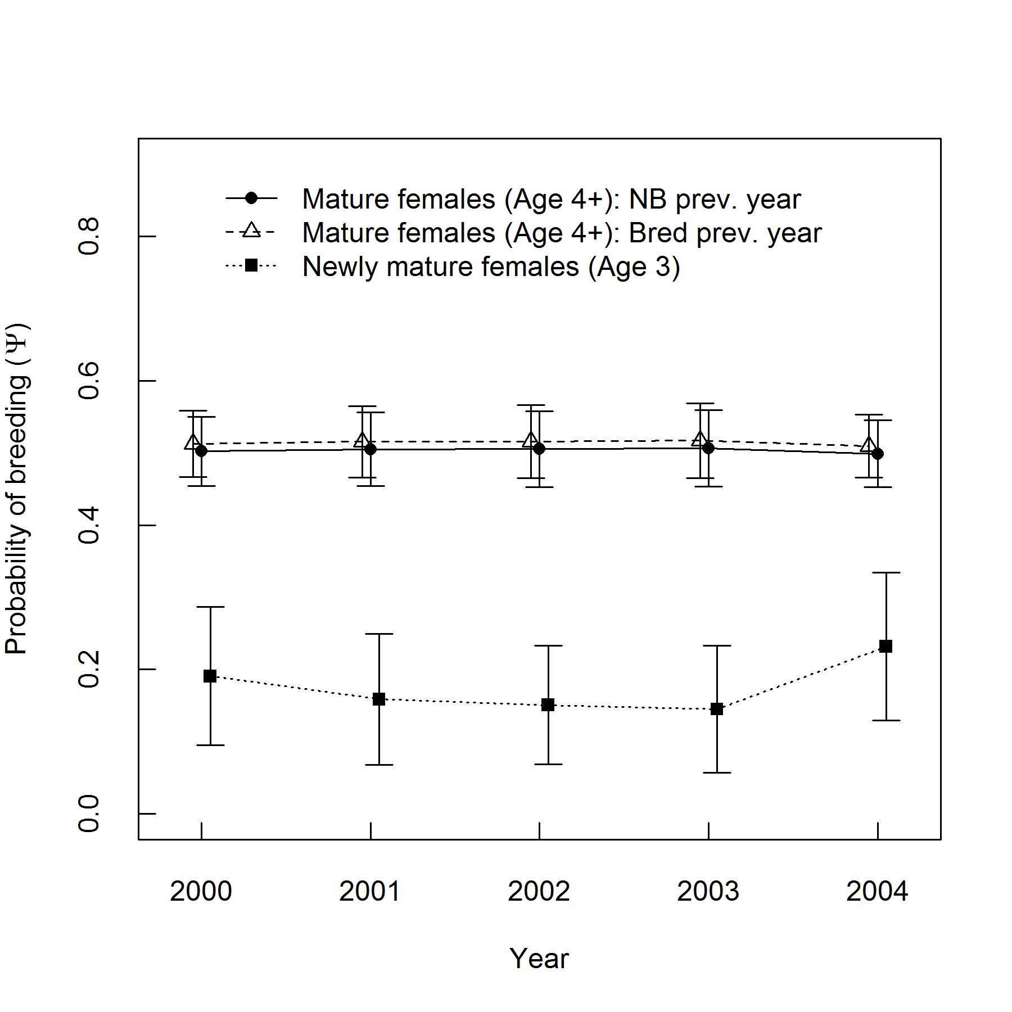
Figure 2.

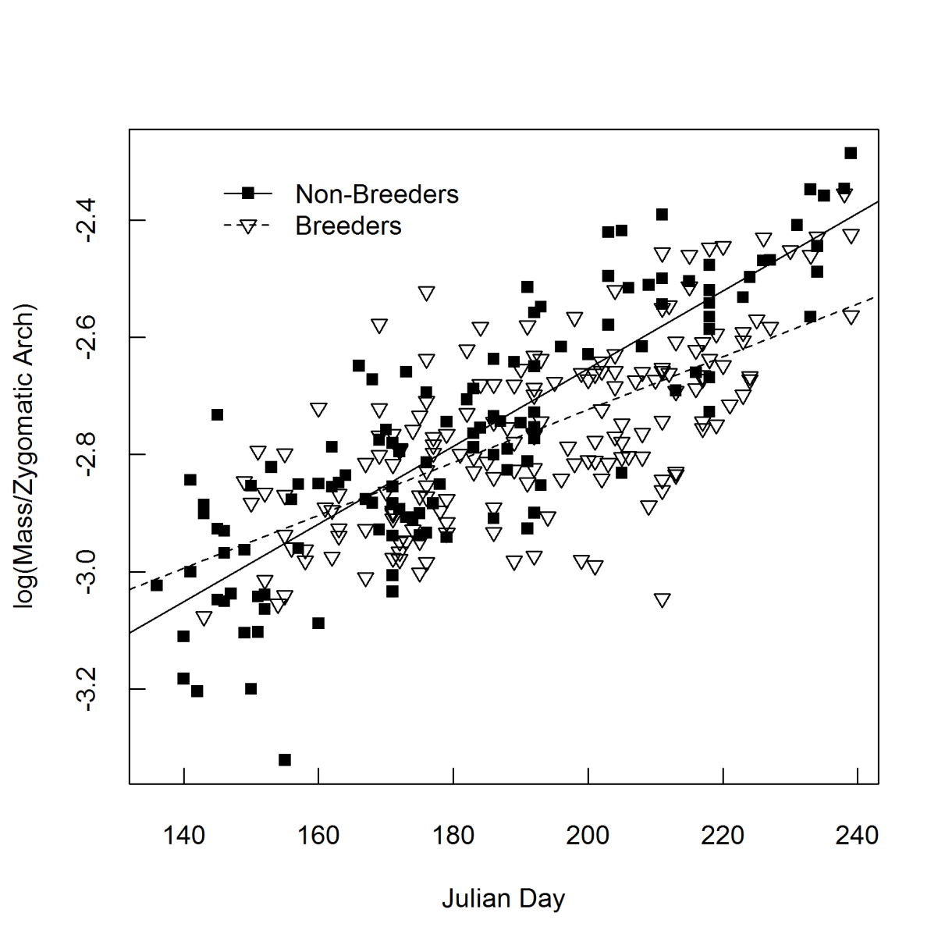
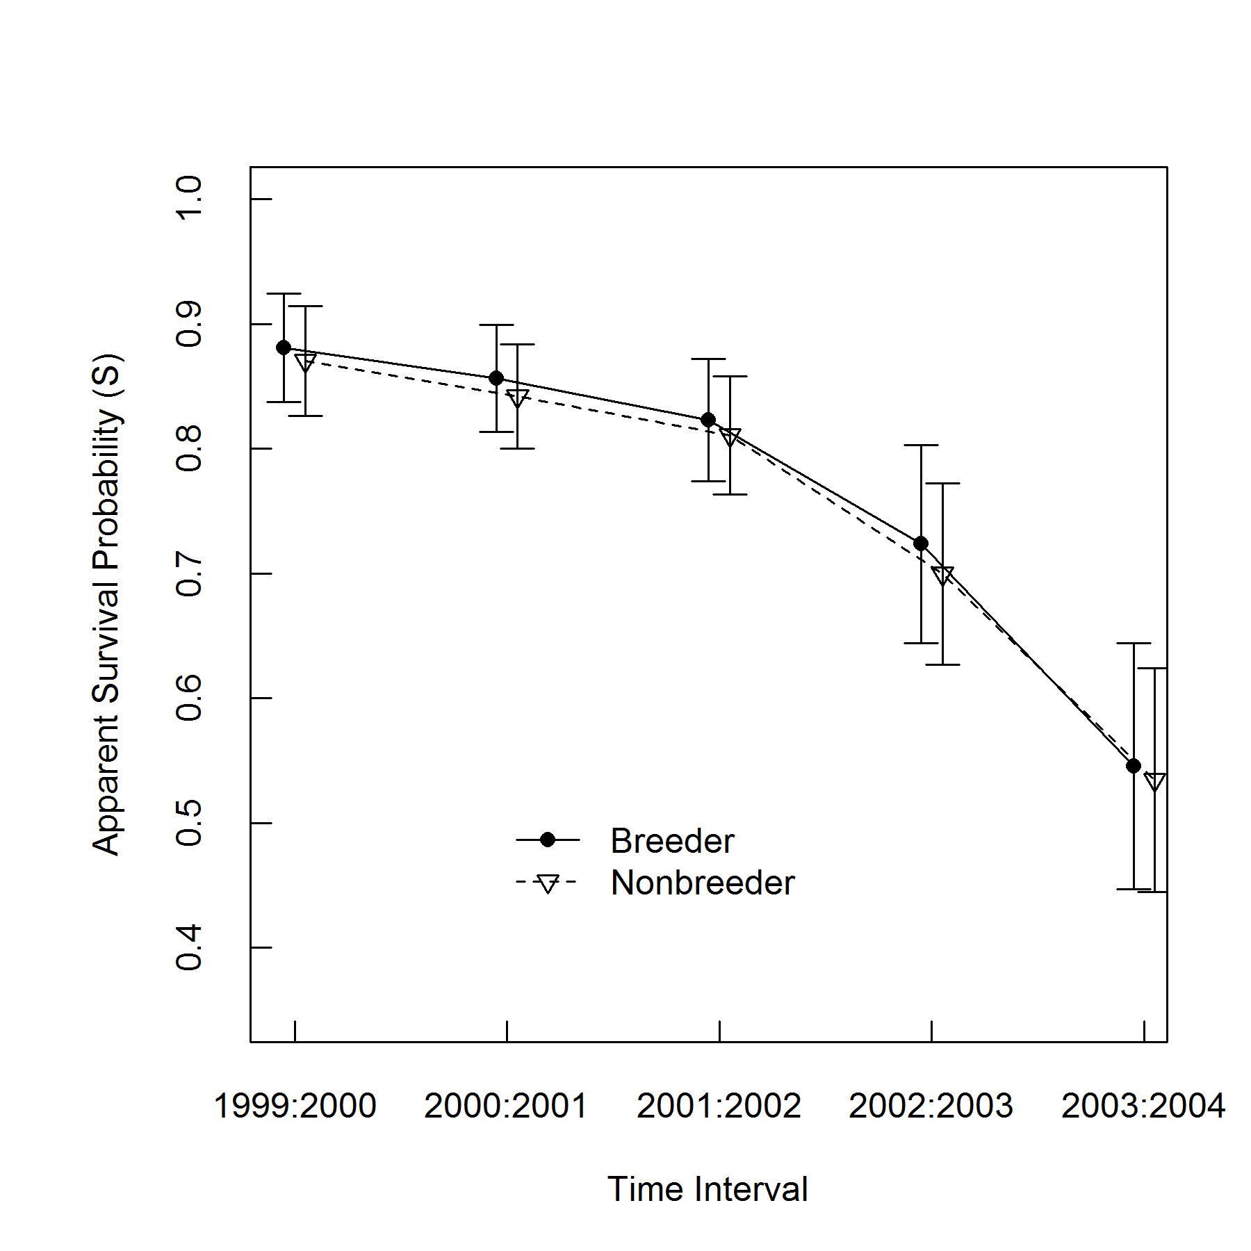
Figure 3.

Figure 3.

